Behaviour Policy

Debden C of E Primary Academy

Reviewed by: Sarah Bailey September 2025

Shared with staff: September 2025

Shared with Governors: September 2025

Review date: September 2026

**CONTENTS**

**POLICY STATEMENT** 2

**AIMS** 2

**LEGISLATION, STATUTORY REQUIREMENTS AND GUIDANCE** 3

**DEFINITIONS** 3

**ROLES AND RESPONSIBILITIES** 4

**BEHAVIOUR EXPECTATIONS** 6

**ENCOURAGING POSITIVE BEHAVIOUR** 7

**SANCTIONS SYSTEM** 9

**SERIOUS SANCTIONS** 9

**PUPILS WITH SEND** 10

**SAFEGUARDING** 11

**REPORTING BEHAVIOUR INCIDENTS** 12

**PEER-ON-PEER ABUSE** 12

**REASONABLE FORCE** 12

**CONFISCATION, SEARCHES, SCREENING** 13

**PARENTS** 15

**OFFSITE MISBEHAVIOUR** 16

**ONLINE MISBEHAVIOUR** 16

**SUSPECTED CRIMINAL BEHAVIOUR** 16

**SEXUAL HARASSMENT/ SEXUAL VIOLENCE** 17

**MALICIOUS ALLEGATIONS** 17

**PUPIL TRANSITION** 17

**TRAINING** 18

**MONITORING ARRANGEMENTS** 18

# **POLICY STATEMENT**

Debden Primary Church of England Academy is committed to creating an environment in which exemplary behaviour is at the heart of productive learning. Everyone in the school is expected to take pride in their high levels of personal conduct, accept responsibility for their behaviour, and expect others to do the same.

In committing to the highest standards of behaviour, we provide the best possible opportunities for the children in our care to meet the core components of our school vision, which is to provide a highly-purposeful, caring Christian community, in which our children:

-Progress exceptionally well academically, across a broad and knowledge-rich curriculum;

-Develop into confident, compassionate, well-rounded individuals;

-Become equipped with the learning skills needed to deal with future challenges;

-Create happy, positive memories of their childhood.

-Develop a global perspective, inspiring them to become active, responsible and empathetic global citizens.

Whilst our behaviour policy enables our staff to act with a consistent approach (using a number of consistent rules and expectations) it also encourages staff to act utilising professional judgement, as opposed to relying on rigid compliance. Our approach to behaviour management is strongly governed by the Christian Values that we promote and teach across our school.

# **AIMS**

This policy aims to:

* Create a positive culture that promotes excellent behaviour, ensuring that all pupils have the opportunity to learn in a calm, safe and supportive environment
* Establish a whole-school approach to maintaining high standards of behaviour that reflect the values of the school
* Outline the expectations and consequences of behaviour
* Provide a consistent approach to behaviour management that is applied equally to all pupils
* Define what we consider to be unacceptable behaviour, including bullying and discrimination.

*Good behaviour in schools is central to a good education. Schools need to manage behaviour well so they can provide calm, safe and supportive environments which children and young people want to attend and where they can learn and thrive. Being taught how to behave well and appropriately within the context they’re in is vital for all pupils to succeed personally.* (DfE, Behaviour in Schools, February 2024).

# **LEGISLATION, STATUTORY REQUIREMENTS AND GUIDANCE**

This policy is based on legislation and advice from the Department for Education (DfE) on:

This policy is based on legislation and advice from the Department for Education (DfE) on:

[Behaviour in schools: advice for headteachers and school staff 2024](https://www.gov.uk/government/publications/behaviour-in-schools--2)

* [Searching, screening and confiscation: advice for schools 2022](https://www.gov.uk/government/publications/searching-screening-and-confiscation)
* [The Equality Act 2010](https://www.gov.uk/government/publications/equality-act-2010-advice-for-schools)
* [Keeping Children Safe in Education](https://www.gov.uk/government/publications/keeping-children-safe-in-education--2)

[Suspension and permanent exclusion from maintained schools, academies and pupil referral units in England, including pupil movement](https://www.gov.uk/government/publications/school-exclusion)

[Use of reasonable force in schools](https://www.gov.uk/government/publications/use-of-reasonable-force-in-schools)

* [Supporting pupils with medical conditions at school](https://www.gov.uk/government/publications/supporting-pupils-at-school-with-medical-conditions--3)
* [Special Educational Needs and Disability (SEND) Code of Practice](https://www.gov.uk/government/publications/send-code-of-practice-0-to-25)
* [Sharing nudes and semi-nudes: advice for education settings working with children and young people](https://www.gov.uk/government/publications/sharing-nudes-and-semi-nudes-advice-for-education-settings-working-with-children-and-young-people)

In addition, this policy is based on:

* Schedule 1 of the [Education (Independent School Standards) Regulations 2014](http://www.legislation.gov.uk/uksi/2014/3283/schedule/made); paragraph 7 outlines a school’s duty to safeguard and promote the welfare of children, paragraph 9 requires the school to have a written behaviour policy and paragraph 10 requires the school to have an anti-bullying strategy
* [DfE guidance](https://www.gov.uk/guidance/what-academies-free-schools-and-colleges-should-publish-online#behaviour-policy) explaining that academies should publish their behaviour policy and anti-bullying strategy

This policy complies with our funding agreement and articles of association.

# **DEFINITIONS**

**Misbehaviour** is defined as:

* Disruption in lessons, in corridors between lessons, and at break and lunchtimes
* Non-completion of classwork or homework
* Poor attitude
* Incorrect uniform

**Serious misbehaviour** is defined as:

* Repeated breaches of the school rules
* Any form of bullying
* Sexual violence, such as rape, assault by penetration, or sexual assault (intentional sexual touching without consent)
* Sexual harassment, meaning unwanted conduct of a sexual nature, such as:
* Sexual comments
* Sexual jokes or taunting
* Physical behaviour like interfering with clothes
* Online sexual harassment, such as unwanted sexual comments and messages (including on social media), sharing of nude or semi-nude images and/or videos, or sharing of unwanted explicit content.
* Vandalism
* Theft
* Fighting
* Smoking
* Racist, sexist, homophobic or discriminatory behaviour
* Possession of any prohibited items. These are:
* Knives or weapons
* Alcohol
* Illegal drugs
* Stolen items
* Tobacco and cigarette papers
* Fireworks
* Pornographic images
* Any article a staff member reasonably suspects has been, or is likely to be, used to commit an offence, or to cause personal injury to, or damage to the property of, any person (including the pupil)
* Mobile phones or electronic devices

# **ROLES AND RESPONSIBILITIES**

**The Governing Board**

The governing board is responsible for monitoring this behaviour policy’s effectiveness and holding the Headteacher to account for its implementation.

**The Headteacher**

The Headteacher is responsible for:

-Reviewing and approving this behaviour policy;

-Ensuring that the school environment encourages positive behaviour;

-Supporting staff to deal effectively with poor behaviour;

-Monitoring how staff implement this policy to ensure rewards and sanctions are applied fairly and consistently to all groups of pupils;

-Ensuring that all staff understand the behavioural expectations and the importance of maintaining them;

-Providing new staff with a clear induction into the school’s behavioural culture to ensure they understand its rules and routines, and how best to support all pupils to participate fully;

-Offering appropriate training in behaviour management, and the impact of special educational needs and disabilities (SEND) and mental health needs on behaviour, to any staff who require it, so they can fulfil their duties set out in this policy;

-Ensuring this policy works alongside the safeguarding policy to offer pupils both sanctions and support when necessary;

-Ensuring that the data from the behaviour log is reviewed regularly, to make sure that no groups of pupils are being disproportionately impacted by this policy.

**Staff**

Staff are responsible for:

-Creating a calm and safe environment for pupils, in which learning, achievement and positive behaviour choices are celebrated;

-Establishing and maintaining clear boundaries of acceptable pupil behaviour;

-Implementing the behaviour policy fairly and consistently;

-Communicating the school’s expectations, routines, values and standards through teaching behaviour and in every interaction with pupils;

-Modelling expected behaviour and positive relationships;

-Providing a personalised approach to the specific behavioural needs of particular pupils;

-Considering their own behaviour on the school culture and how they can uphold school rules and expectations;

-Recording behaviour incidents promptly

-Challenging pupils to meet the school’s expectations;

The Senior Leadership Team (SLT) will support staff in responding to behaviour incidents.

**Parents and Carers**

Parents and carers, where possible, should:

Get to know the school’s behaviour policy;

-Model and reinforce its key ideas with their child where appropriate;

-Support their child in adhering to the school’s behaviour policy;

-Inform the school of any changes in circumstances that may affect their child’s behaviour;

-Discuss any behavioural concerns with the class teacher promptly;

-Participate in any pastoral work following misbehaviour (for example: attending reviews of specific behaviour interventions);

-Raise any concerns about the management of behaviour with the school directly, whilst continuing to work in partnership with the school;

-Take part in the life of the school and its culture;

The school will endeavour to build a positive relationship with parents and carers by keeping them informed about developments in their child's behaviour and the school’s policy and working in collaboration with them to tackle behavioural issues.

**Pupils**

Pupils will be made aware of the following during their induction into the behaviour culture (and at regular points throughout their education at our school):

* The expected standard of behaviour they should be displaying at school;
* That they have a duty to follow the behaviour policy;
* The school’s key rules and routines;
* The rewards they can earn for meeting and exceeding behaviour standards, and the consequences they will face if they don’t meet these standards;
* The pastoral support that is available to them to help them meet the behavioural standards;
* An understanding of the school’s behaviour policy and wider culture;

Pupils will be asked to give feedback on their experience of the behaviour culture to support the evaluation, improvement and implementation of the behaviour policy.

# **BEHAVIOUR EXPECTATIONS**

Our school behaviour motto is ‘Be Kind, Be Brave, Be Safe, Behave’ (see Appendix B) which encompasses all of the behaviour expectations that we have collaboratively defined as a staff team.

Whilst the below list is not exhaustive, it offers a clear indication of the standards of behaviour expected at the school:

|  |  |
| --- | --- |
| BE KIND  -Show compassion for other people, including staff and other children;  -Genuinely care about the feelings of others. Do the right thing because we want to, not because of fear of sanction.  -Treat other people with respect. Treat them how we would wish to be treated. | BE BRAVE  -‘Have a go’ in our learning, even when it is new or unfamiliar to us. Understand that learning is a process. Focus on progress and getting better.  -Keep trying when things are difficult.  -Show the bravery to make the right behaviour choices, even when others are not. |
| BE SAFE  -Follow the rules of the classroom, playground and other areas of the schools. Listen carefully to the adults who supervise us.  -Don’t do anything that may put another person, ourselves or our school in danger. | BEHAVE  -Always think carefully about our choices.  -Try to act in ways that make those around us feel proud of us, and that help us to feel proud of ourselves. |

*Classroom Expectations*

* We demonstrate an eagerness and readiness to learn;
* We listen attentively to staff and their peers, turn-taking and showing respect to others;
* We walk around classrooms and indoor areas sensibly;
* We carefully look after school equipment, in addition to their own and other people’s equipment;
* We respect classrooms as working environments, and knock before we enter classrooms and working spaces;
* We respect the personal space of others;
* We show the bravery to try new things and see failure as a learning experience;
* We show independence when appropriate, and strong teamwork and collaboration skills when working with others;
* We try our hardest, exhibiting resilience when we find tasks challenging;
* We take pride in our work, presenting it neatly and to the best of our ability.

*At break, lunch, and less structured times;*

* We are compassionate to others who need our support (including those who are sat alone at our house benches);
* We walk when we are inside the school building;
* We look after the outdoor environment and resources, ensuring that they remain clean, tidy and safe;
* We communicate politely and respectfully, both to their peers and to adults;
* We respect the school rotas, understanding when it is our turn to utilise facilities/ resources;
* We are kind and polite to other children, and try to ensure that no child feels isolated or left out;
* We use our ‘indoor voices’ and ‘outdoor voices’ appropriately;
* We are helpful towards other children and adults.

We do not allow children to have mobile phones on them in person around the school building. If a child is required to have a mobile phone in school for any reason, this must be agreed with the Headteacher, and then phone must be left in the front office area.

# **ENCOURAGING POSITIVE BEHAVIOUR**

We aim to encourage children to behave positively through a number of different strategies:

* Our Christian Values (below) are entwined with our school vision to ‘Nurture, Progress, Excel.’ They are promoted through collective worship and consistently reinforced across the school:

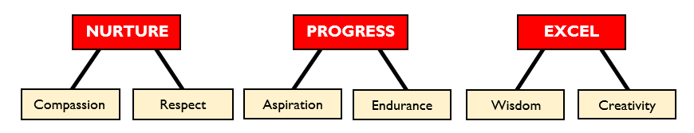

* Our behaviour for learning boards (see Appendix A) are used consistently and fairly in all classes, with children able to reach gold when their learning behaviours are ‘above and beyond.’
* We ensure that reminders of good behaviour and high expectations are displayed around the school – including our behaviour motto (Be Kind, Be Brave, Be Safe, Behave – see Appendix B).
* We enable pupil voice and personal development through our student council.
* We teach the components of good citizenship and community spirit, as well as developing children’s social, emotional, and behavioural skills through our PSHE curriculum;
* We hold a weekly celebration assembly, in which we reward exceptional behaviour for learning, including those children reaching ‘Gold’ on the behaviour for learning boards.
* Each class has a “Star of the week” nominated by each class teacher and awarded by the headteacher in celebration assembly.
* We hold regular events to support and raise the profile of positive behaviour habits, for example ‘Anti-Bullying Week’ and ‘Wellbeing Week.’

*Behaviour for Learning Boards:* (see appendix A) Each classroom has a behaviour for learning board clearly displayed at the front of the room. The behaviour for learning system serves to reinforce positive learning behaviours, and structure sanctions at times in which they are necessary. Children may be moved ‘up the board’ to recognise excellent behaviour for learning choices. They may also move down the board if they make behaviour choices that are not aligned with our school behaviour values. As a staff team, we agree that verbal praise and warnings should always serve as the predominant mechanism for encouraging positive behaviour, and that our behaviour for learning system should be employed only to recognise what is ‘above and beyond’, or conversely, repeated/serious behaviour infractions.

*Praise and Celebration:* Moving ‘up the board’ represents exceptional learning behaviours. Across the week, any children who move all the way up to ‘gold’ (the top standard on the behaviour board) are rewarded with a house token, and a position on the ‘roll of honour’ in the school achievement assembly. Positions on the board also correspond to the following House Points:

Bronze – Well done!

Silver – 1 point

Gold – 2 points

Children can also receive house points for their achievements in school events across the year (e.g. sports day, wellbeing week, etc.) The house with the most points at the end of each half-term receives a house reward (e.g. an additional playtime or fun activity).

*The Star of the Week*: Each week, every class teacher selects at least one ‘Star of the Week.’ This is announced in achievement assembly and the child is rewarded with a certificate.

*The Behaviour Hero*: Every week, one child from the school who has exhibited outstanding behaviour choices is selected by our learning support assistants and midday supervisors. This child receives a certificate and is entered into a termly prize draw.

*Achievement Assembly*: All parents are invited to our weekly celebration assemblies, in which the Star of the Week, Behaviour Hero and Gold Roll of Honour are announced. We decide on the Star of the Week and Behaviour Hero on a Friday morning and aim to inform parents should their child be in line to win the award – this increases the possibility that they may be able to attend and join in celebrating their child’s success.

# **SANCTIONS SYSTEM**

*Verbal Warnings*: Our first approach is to always highlight negative behaviour choices in an appropriate manner. Where infractions are only very minor, we utilise kind but firm reminders and verbal warnings.

*Behaviour for Learning Board:* ‘Moving down the board’ represents occasions in which children’s negative behaviour choices are repeated and/or severe. We do so in alignment with our ‘Managing Behaviour Flowchart’ (see Appendix C).

-Moving down to yellow on the board serves as a formal warning, for instances of behaviour that are relatively minor and ‘one-offs.’ Examples may include calling out or not being adequately prepared for learning.

-Moving down to amber on the board is reserved for more moderate or repeated negative behaviour choices. This is accompanied by a classroom sanction, for example staying in to complete learning or writing an apology letter to someone that they have upset.

-More serious or persistent instances of negative behaviour result in the child being moved down to red on the board. This results in the child being sent to the Headteacher or Deputy Headteacher, who decide on the appropriate sanction.

-Moving down to either amber or red is accompanied by a phone call home to parents and a behaviour incident form being completed.

# **SERIOUS SANCTIONS**

*Removal from classrooms:*In response to serious or persistent breaches of this policy, the school may remove the pupil from the classroom for a limited time.

Pupils who have been removed will continue to receive education under the supervision of a member of staff that is meaningful, but it may differ from the mainstream curriculum.

Removal is a serious sanction and will only be used in response to serious misbehaviour. Staff will only remove pupils from the classroom once other behavioural strategies have been attempted, unless the behaviour is so extreme as to warrant immediate removal.

Removal can be used to:

Restore order if the pupil is being unreasonably disruptive

Maintain the safety of all pupils

Allow the disruptive pupil to continue their learning in a managed environment

Allow the disruptive pupil to regain calm in a safe space

Pupils who have been removed from the classroom are supervised by the Headteacher or Deputy Headteacher (depending upon who is available) and will be removed for a maximum of half a day. Pupils will not be removed from classrooms for prolonged periods of time without the explicit agreement of the Headteacher.

Pupils should be reintegrated into the classroom as soon as appropriate and safe to do so. The school will consider what support is needed to help a pupil successfully reintegrate into the classroom and meet the expected standards of behaviour.

Parents will be informed on the same day that their child is removed from the classroom.

The school will consider an alternative approach to behaviour management for pupils who are frequently removed from class, such as**:**

-Meetings with the learning mentor

-Use of teaching assistants

-Short term behaviour report cards

-Long term behaviour plans

-Pupil support units

-Multi-agency assessment.

Staff will record all incidents of removal from the classroom along with details of the incident that led to the removal, and any protected characteristics of the pupil in the behaviour log.

*Suspensions and Exclusions:* In the most severe instances of dangerous/ violent/ extremely negative behaviour, the Headteacher may invoke the Suspension and Exclusion Policy and consider a suspension (formerly referred to as a fixed term exclusion) for a period of up to 5 days. In extreme cases a permanent exclusion may be considered. The Governing Body will be notified of this in advance (where it is possible to do so).

# **PUPILS WITH SEND**

The school recognises that pupils’ behaviour may be impacted by a special educational need or disability (SEND).

When incidents of misbehaviour arise, we will consider them in relation to a pupil’s SEND, although we recognise that not every incident of misbehaviour will be connected to their SEND. Decisions on whether a pupil’s SEND had an impact on an incident of misbehaviour will be made on a case-by-case basis.

When dealing with misbehaviour from pupils with SEND, especially where their SEND affects their behaviour, the school will balance their legal duties when making decisions about enforcing the behaviour policy. The legal duties include:

Taking reasonable steps to avoid causing any substantial disadvantage to a disabled pupil caused by the school’s policies or practices ([Equality Act 2010](https://www.gov.uk/government/publications/equality-act-2010-advice-for-schools))

Using our best endeavours to meet the needs of pupils with SEND ([Children and Families Act 2014](https://www.legislation.gov.uk/ukpga/2014/6/contents/enacted))

If a pupil has an education, health and care (EHC) plan, the provisions set out in that plan must be secured and the school must co-operate with the local authority and other bodies

As part of meeting these duties, the school will anticipate, as far as possible, all likely triggers of misbehaviour, and put in place support to prevent these from occurring.

Any preventative measures will take into account the specific circumstances and requirements of the pupil concerned. Examples may include:

-Short, planned movement breaks for a pupil with SEND who finds it difficult to sit still for long

-Adjusting seating plans to allow a pupil with visual or hearing impairment to sit in sight of the teacher

-Adjusting uniform requirements for a pupil with sensory issues or who has severe eczema

-Training for staff in understanding conditions such as autism

-Use of separation spaces (sensory zones or nurture rooms) where pupils can regulate their emotions during a moment of sensory overload.

Adapting sanctions for pupils with SEND

When considering a behavioural sanction for a pupil with SEND, the school will take into account:

-Whether the pupil was unable to understand the rule or instruction?

-Whether the pupil was unable to act differently at the time as a result of their SEND?

-Whether the pupil is likely to behave aggressively due to their particular SEND?

If the answer to any of these questions is yes, it may be unlawful for the school to sanction the pupil for the behaviour.

The school will then assess if it is appropriate to use a sanction and if so, whether any reasonable adjustments need to be made to the sanction.

Considering whether a pupil displaying challenging behaviour may have unidentified SEND

The school’s special educational needs co-ordinator (SENDCO) may evaluate a pupil who exhibits challenging behaviour to determine whether they have any underlying needs that are not currently being met.

Where necessary, support and advice will also be sought from specialist teachers, an educational psychologist, medical practitioners and/or others, to identify or support specific needs.

When acute needs are identified in a pupil, we will liaise with external agencies and plan support programmes for that child. We will work with parents to create the plan and review it on a regular basis.

Pupils with an education, health and care (EHC) plan

The provisions set out in the EHC plan must be secured and the school will co-operate with the local authority and other bodies.

If the school has a concern about the behaviour of a pupil with an EHC plan, it will make contact with the local authority to discuss the issue. If appropriate, the school may request an emergency review of the EHC plan.

**Supporting pupils following a sanction**

Following a sanction, the school will consider strategies to help pupils to understand how to improve their behaviour and meet the expectations of the school.

This will include:

-A reintegration meeting;

-Daily contact between parents and the teacher/ Headteacher for an agreed time period.

# **SAFEGUARDING**

The school also recognises that changes in behaviour may be an indicator that a pupil is in need of help or protection.

We will consider whether a pupil’s misbehaviour may be linked to them suffering, or being likely to suffer, significant harm.

Where this may be the case, we will follow our child protection and safeguarding policy, and consider whether pastoral support, an early help intervention or a referral to children’s social care is appropriate.

Please refer to our child protection policy for more information.

# **REPORTING BEHAVIOUR INCIDENTS**

A behaviour incident should be logged if it meets any of the below criteria:

* A serious incident (e.g. any incident of physicality, swearing, any type of abuse, disrespectful behaviour towards a peer/ member of staff);
* Persistently bad behavioural choices (e.g. repeatedly calling out, refusing to take part in learning, displaying a negative attitude, etc).
* Any incident that has involved the child moving down to amber or lower on the behaviour for learning board.

Behaviour incidents are recorded on CPOMs (Child Protection Online Monitoring System) under the behaviour section. Staff are to provide as much objective information as possible, including any antecedent to the incident. These are reviewed regularly by the Headteacher and Deputy Headteacher.

# **PEER-ON-PEER ABUSE**

Keeping Children Safe in Education 2022 stresses the need for all staff should to be aware that children can abuse other children (often known as ‘peer-on-peer’ abuse) and that it can happen *‘both inside and outside of school or and online.’* It is also important that all staff *‘recognise the indicators and signs of peer-on-peer abuse and know how to identify it and respond to reports.’* Through regular child protection training, all staff at Debden are aware that even more commonplace negative behaviours (such as name-calling, hitting and pinching) constitute peer-on-peer abuse and may be evidence or precursors of continued/ more severe hidden abuse.

Please note that all more persistent and profound instances of peer-on-peer abuse continue to be recorded with our child protection records. If staff are unsure which form to fill in, they should consult the Designated Safeguarding Lead (Sarah Bailey) for advice.

# **REASONABLE FORCE**

Reasonable force covers a range of interventions that involve physical contact with pupils. All members of staff have a duty to use reasonable force, in the following circumstances, to prevent a pupil from:

-Causing disorder

-Hurting themselves or others

-Damaging property

-Committing an offence.

Incidents of reasonable force must:

-Always be used as a last resort

-Be applied using the minimum amount of force and for the minimum amount of time possible

-Be used in a way that maintains the safety and dignity of all concerned

-Never be used as a form of punishment

Significant incidents of using reasonable force (for example, restraining a child or physically removing a child from a dangerous situation) should be recorded using the school’s restraint log, and should be reported to parents. When considering using reasonable force, staff should, in considering the risks, carefully recognise any specific vulnerabilities of the pupil, including SEND, mental health needs or medical conditions.

# **CONFISCATION, SEARCHES, SCREENING**

Searching, screening and confiscation is conducted in line with the DfE’s [latest guidance on searching, screening and confiscation](https://www.gov.uk/government/publications/searching-screening-and-confiscation).

**Confiscation**

Any prohibited items found in a pupil’s possession as a result of a search will be confiscated. These items will not be returned to the pupil.

We will also confiscate any item that is harmful or detrimental to school discipline. These items will be returned to pupils after discussion with senior leaders and parents, if appropriate.

**Searching a pupil**

Searches will only be carried out by a member of staff who has been authorised to do so by the Headteacher, or by the Headteacher themselves and there will be another member of staff present as a witness to the search. An authorised member of staff can carry out a search without another member of staff as a witness if:

-The authorised member of staff carrying out the search reasonably believes there is risk that serious harm will be caused to a person if the search is not carried out as a matter of urgency;

-It is not reasonably practicable for the search to be carried out in the presence of another member of staff.

When an authorised member of staff conducts a search without a witness they should immediately report this to another member of staff and ensure a written record of the search is kept. If the authorised member of staff considers a search to be necessary, but is not required urgently, they will seek the advice of the Headteacher, designated safeguarding lead (or deputy) or pastoral member of staff who may have more information about the pupil. During this time the pupil will be supervised and kept away from other pupils.

An appropriate location for the search will be found. Where possible, this will be away from other pupils. The search will only take place on the school premises or where the member of staff has lawful control or charge of the pupil, for example on a school trip.

Before carrying out a search the authorised member of staff will:

-Assess whether there is an urgent need for a search

-Assess whether not doing the search would put other pupils or staff at risk

-Consider whether the search would pose a safeguarding risk to the pupil

-Explain to the pupil why they are being searched

-Explain to the pupil what a search entails – e.g. I will ask you to turn out your pockets and remove your scarf

-Explain how and where the search will be carried out

-Give the pupil the opportunity to ask questions

-Seek the pupil’s co-operation

-If the pupil refuses to agree to a search, the member of staff can give an appropriate behaviour sanction.

-If they still refuse to co-operate, the member of staff will contact the Headteacher/ DSL to try and determine why the pupil is refusing to comply.

The authorised member of staff will then decide whether to use reasonable force to search the pupil. This decision will be made on a case-by-case basis, taking into consideration whether conducting the search will prevent the pupil harming themselves or others, damaging property or from causing disorder.

An authorised member of staff may search a pupil’s outer clothing, pockets, possessions, desks or lockers.

Outer clothing includes:

-Any item of clothing that is not worn immediately over a garment that is being worn wholly next to the skin or being worn as underwear (e.g. a jumper or jacket being worn over a t-shirt)

-Hats, scarves, gloves, shoes, boots

-Searching pupils’ possessions.

Possessions means any items that the pupil has or appears to have control of, including:

-Desks

-Lockers

-Bags

A pupil’s possessions can be searched for any item if the pupil agrees to the search. If the pupil does not agree to the search, staff can still carry out a search for prohibited items and items identified in the school rules. An authorised member of staff can search a pupil’s possessions when the pupil and another member of staff are present.

If there is a serious risk of harm if the search is not conducted immediately, or it is not reasonably practicable to summon another member of staff, the search can be carried out by a single authorised member of staff.

**Informing the Designating Safeguarding Lead (DSL)**

The staff member who carried out the search should inform the DSL without delay:

-Of any incidents where the member of staff had reasonable grounds to suspect a pupil was in possession of a prohibited item.

-If they believe that a search has revealed a safeguarding risk

All searches for prohibited items, including incidents where no items were found, will be recorded in the school’s safeguarding system.

**Informing parents**

Parents will always be informed of any search for a prohibited item. A member of staff will tell the parents as soon as is reasonably practicable:

-What happened

-What was found, if anything

-What has been confiscated, if anything

-What action the school has taken, including any sanctions that have been applied to their child.

**Support after a search**

Irrespective of whether any items are found as the result of any search, the school will consider whether the pupil may be suffering or likely to suffer harm and whether any specific support is needed (due to the reasons for the search, the search itself, or the outcome of the search).

If this is the case, staff will follow the school’s safeguarding policy and speak to the designated safeguarding lead (DSL). The DSL will consider if pastoral support, an early help intervention or a referral to children’s social care is appropriate.

# **PARENTS**

Parents have a vital role in promoting good behaviour in school and effective home/school liaison is crucial. The school expects that all parents give their full support in dealing with their child’s behaviour.

We ask parents to inform us straightway of:

* Any behaviour difficulties they may be experiencing at home
* Any trauma which may affect their child’s behaviour or performance at school
* Any concerns they may have about issues going on at school which are affecting their child

The school will endeavour to achieve effective home/school liaison through:

* Promoting an open-door policy through a warm and welcoming environment within school
* Giving parents regular constructive and positive comments on their child’s progress and behaviour in school through such media as Home/School Link Books, telephone calls, drop-ins after school etc.
* Encouraging parents to come into school regularly
* Keeping parents informed of school activities
* Involving parents at an early stage in any disciplinary issues

# **OFFSITE MISBEHAVIOUR**

Sanctions may be applied where a pupil has misbehaved off-site when representing the school. This means misbehaviour when the pupil is:

-Taking part in any school-organised or school-related activity (e.g. school trips)

-Travelling to or from school

-Wearing school uniform

-In any other way identifiable as a pupil of our school

Sanctions may also be applied where a pupil has misbehaved off-site, at any time, whether or not the conditions above apply, if the misbehaviour:

-Could have repercussions for the orderly running of the school

-Poses a threat to another pupil

-Could adversely affect the reputation of the school

Sanctions will only be given out on school premises or elsewhere when the pupil is under the lawful control of a staff member (e.g. on a school-organised trip).

# **ONLINE MISBEHAVIOUR**

The school can issue behaviour sanctions to pupils for online misbehaviour when:

-It poses a threat or causes harm to another pupil

-It could have repercussions for the orderly running of the school

-It adversely affects the reputation of the school

-The pupil is identifiable as a member of the school

Sanctions will only be given out on school premises or elsewhere when the pupil is under the lawful control of a staff member.

# **SUSPECTED CRIMINAL BEHAVIOUR**

If a pupil is suspected of criminal behaviour, the school will make an initial assessment of whether to report the incident to the police.

When establishing the facts, the school will endeavour to preserve any relevant evidence to hand over to the police.

If a decision is made to report the matter to the police, the Headteacher will make the report.

The school will not interfere with any police action taken. However, the school may continue to follow its own investigation procedure and enforce sanctions, as long as it does not conflict with police action.

If a report to the police is made, the designated safeguarding lead (DSL) will make a tandem report to children’s social care, if appropriate.

# **SEXUAL HARASSMENT/ SEXUAL VIOLENCE**

The school will ensure that all incidents of sexual harassment and/or violence are met with a suitable response, and never ignored.

Pupils are encouraged to report anything that makes them uncomfortable, no matter how ‘small’ they feel it might be.

The school’s response will be:

  -Proportionate

  -Considered

  -Supportive

 -Decided on a case-by-case basis

The school has procedures in place to respond to any allegations or concerns regarding a child’s safety or wellbeing. These include clear processes for:

Responding to a report

Carrying out risk assessments, where appropriate, to help determine whether to:

* + Manage the incident internally
  + Refer to early help
  + Refer to children’s social care
  + Report to the police

Please refer to our child protection policy for more information.

# **MALICIOUS ALLEGATIONS**

Where a pupil makes an allegation against a member of staff and that allegation is shown to have been deliberately invented or malicious, the school will consider whether to discipline the pupil in accordance with this policy.

Where a pupil makes an allegation of sexual violence or sexual harassment against another pupil and that allegation is shown to have been deliberately invented or malicious, the school will consider whether to discipline the pupil in accordance with this policy.

In all cases where an allegation is determined to be unsubstantiated, unfounded, false or malicious, the school (in collaboration with the local authority designated officer (LADO), where relevant) will consider whether the pupil who made the allegation is in need of help, or the allegation may have been a cry for help. If so, a referral to children’s social care may be appropriate.

The school will also consider the pastoral needs of staff and pupils accused of misconduct.

Please refer to our Child Protection Policy.

# **PUPIL TRANSITION**

The school will support incoming pupils to meet behaviour standards by offering an induction process to familiarise them with the behaviour policy and the wider school culture.

To ensure a smooth transition to the next year, pupils have transition sessions with their new teacher(s). In addition, staff members hold transition meetings.

To ensure behaviour is continually monitored and the right support is in place, information related to pupil behaviour issues may be transferred to relevant staff at the start of the term or year.

# **TRAINING**

Staff are provided with regular training on managing behaviour, including training on:

-The needs of the pupils at the school

-How SEND and mental health needs impact behaviour

Behaviour management will also form part of continuing professional development.

# **MONITORING ARRANGEMENTS**

The school will collect data on the following:

-Behavioural incidents, including removal from the classroom

-Attendance, permanent exclusion and suspension

-Use of pupil support units, off-site directions and managed moves

-Incidents of searching, screening and confiscation

-Anonymous surveys for staff, pupils, governors, trustees and other stakeholders on their perceptions and experiences of the school behaviour culture

The data will be analysed every term by the Headteacher and will be shown in the termly report to Governors.

The school will use the results of this analysis to make sure it is meeting its duties under the Equality Act 2010. If any trends or disparities between groups of pupils are identified by this analysis, the school will review its policies to tackle it.

This behaviour policy will be reviewed by the Headteacher at least annually, or more frequently, if needed, to address findings from the regular monitoring of the behaviour data.At each review, the policy will be approved by the governing body.

**Links with other policies**

This behaviour policy is linked to the following policies:

Suspensions and exclusion policy

Child protection policy

Anti-bullying policy

**APPENDIX A – Learning Behaviour Board**

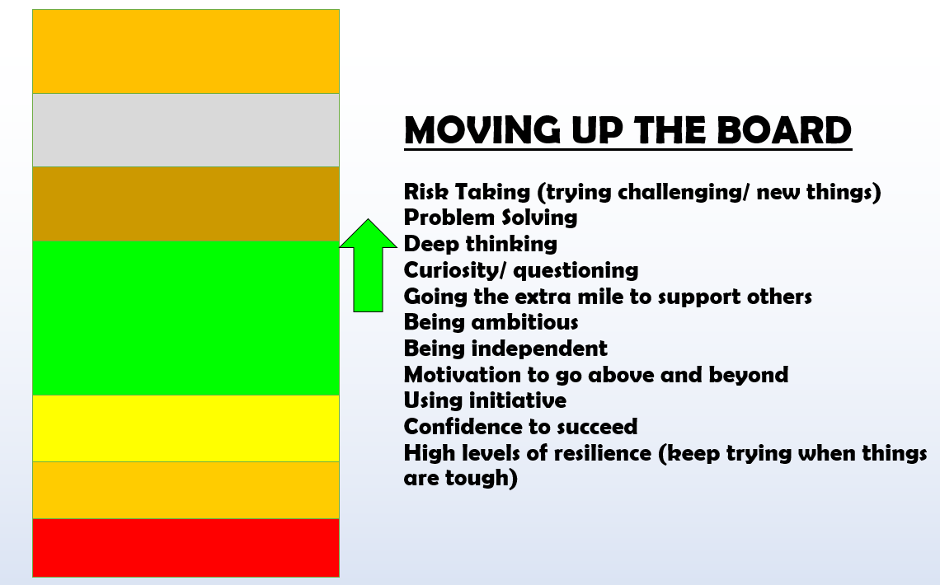

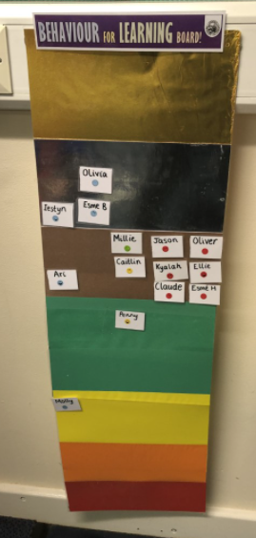

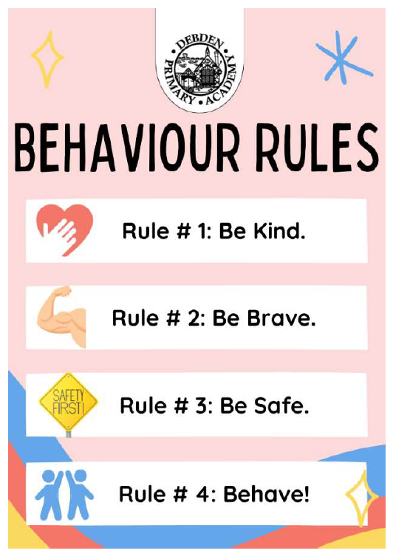**APPENDIX B – Our School’s Motto**

**APPENDIX C – Behaviour Incident Form**

**APPENDIX C – Managing Behaviour Flowchart**

