Relationships and Sex Education Policy

Debden C of E Primary Academy

Reviewed by: Heather Rowe and Julia Bacon
Shared with staff: June 2026
Shared with Governors: June 2026
Review date: June 2027

POLICY STATEMENT
Debden Primary Academy is committed to providing children with the knowledge, skills and understanding they need to lead confident, healthy, independent lives and to become informed, active and responsible citizens. In providing children with an understanding of healthy and respectful relationships and appropriate boundaries, we consider effective RSE to be a fundamental part of our approach to supporting pupils to grow into confident, caring, responsible and respectful young citizens.
At Debden, RSE is taught within the Personal, Social, Health and Economic (PSHE) education curriculum. In addition, some aspects of the RSE programme will be covered through:
- Science
- Computing
- Assemblies/worship
- Themed weeks and enrichment days
- Circle time and class discussions
- Whole class reading and story
- PE in the context of health and hygiene

RSE is lifelong learning about personal, physical, moral and emotional development. It should teach children and young people to develop and form positive values, attitudes, personal and social skills, and increase their knowledge and understanding of how to make informed decisions and life choices.
AIMS
The aims of relationships and sex education (RSE) at our school are to:
-Provide a framework in which sensitive, appropriate discussions can take place;
-Prepare pupils for puberty, and give them an understanding of sexual development and the importance of health and hygiene;
-Help pupils develop feelings of self-respect, confidence and empathy;
-Create a positive culture around issues of sexuality and relationships;
-Teach pupils the correct vocabulary to describe themselves and their bodies.

This is an important part of enabling us to promote and enact our wider school vision, which is to enable the children in our care to:
-Progress exceptionally well academically, across a broad and knowledge-rich curriculum;
-Develop into confident compassionate, well-rounded individuals, in a safe, caring, Christian environment;
-Become equipped with the learning skills needed to deal with future challenges;
-Create happy, positive memories of their childhood.
- Care for others through service, kindness, and a sense of justice, becoming active global citizens.

STATUTORY INFORMATION
As a primary academy, we must provide relationships education to all pupils under section 34 of the Children and Social Work Act 2017.
We don’t have to follow the National Curriculum, but we are expected to offer all pupils a curriculum that is similar to the National Curriculum including requirements to teach science. This would include the elements of sex education contained in the science curriculum.
In teaching RSE, we’re required by our funding agreements to have regard to guidance issued by the secretary of state, as outlined in section 403 of the Education Act 1996.
We also have regard to legal duties set out in:
•Sections 406 and 407 of the Education Act 1996
•Part 6, chapter 1 of the Equality Act 2010
•The Public Sector Equality Duty (as set out in section 149 of the Equality Act 2010). This duty requires public bodies to have due regard to the need to eliminate discrimination, advance equality of opportunity and foster good relations between different people when carrying out their activities.
Please refer to our funding agreement and articles of association for more information, which can be found at http://www.greatoakmat.co.uk/web/
At Debden Primary Academy we teach RSE as set out in this policy.

POLICY DEVELOPMENT
This policy has been developed in consultation with staff, governors and parents. The consultation and policy development process involved the following steps:
- Review – The PSHE lead (Heather Rowe), alongside a small working party of teachers, collated all relevant information including relevant national and local guidance;
- Staff consultation – all school staff were given the opportunity to look at the policy and make recommendations;
- Ratification – once amendments were made, the policy was shared with governors and ratified.

DEFINITION
- Relationships Education is defined as teaching about the fundamental building blocks and characteristics of positive relationships, with particular reference to respectful friendships, family relationships, and relationships with other children and with adults, including online.
- Health Education is defined as teaching pupils about physical health and mental wellbeing, focusing on recognising the link between the two and being able to make healthy lifestyle choices
-Sex Education is defined as teaching children how human reproduction occurs, including how a baby is conceived and born. This draws on knowledge of the human life cycle set out in the national curriculum for science. For the purposes of this policy, we specifically identify any non-statutory Sex Education that falls outside of Science and those related elements (the physical changes associated with puberty) within statutory Health Education.

RSE is not about the promotion of sexual activity.

CURRICULUM
Outline of Statutory Requirements
As part of statutory Health Education, children are taught in an age-appropriate way about puberty and the associated physical and emotional changes from Year 4 onwards. As part of the science curriculum, children learn in Year 2 that animals, including humans, have offspring which grow into adults. In Year 5, they describe the changes as humans develop to old age and about how reproduction occurs in some plants and animals.
Alongside this, children in Year 4 are taught to recognise the signs and changes that may occur during the onset of puberty, in preparation for further lessons on this subject which also focus on emotional changes and menstruation in Year 4. These lessons form part of the statutory requirements for Health Education.
More precise details of the exact statutory content taught is outlined in the sections below. We have developed the curriculum taking into account the age, needs and feelings of pupils. If pupils ask questions outside the scope of this policy, teachers will respond in an age-appropriate manner so they are fully informed and do not seek answers online.
Statutory Relationships Education Curriculum Content
Relationships education is embedded within our PSHE curriculum and is set out as per Appendix 1. Our entire PSHE curriculum is adapted from CORAM Life Education, a highly-acclaimed and effective organisation for the planning of a comprehensive primary PSHE curriculum.
Key objectives of the statutory Relationships Education curriculum are outlined below:
Families and people who care for me
By the end of primary school, children should know:
- that families are important for children growing up because they can give love, security and stability.
- the characteristics of healthy family life, commitment to each other, including in times of difficulty, protection and care for children and other family members, the importance of spending time together and sharing each other’s lives.
- that others’ families, either in school or in the wider world, sometimes look different from their family, but that they should respect those differences and know that other children’s families are also characterised by love and care.
- that stable, caring relationships, which may be of different types, are at the heart of happy families, and are important for children’s security as they grow up.
- that marriage represents a formal and legally recognised commitment of two people to each other which is intended to be lifelong.
- how to recognise if family relationships are making them feel unhappy or unsafe, and how to seek help or advice from others if needed.
Caring friendships
Children should know:
- how important friendships are in making us feel happy and secure, and how people choose and make friends.
- the characteristics of friendships, including mutual respect, truthfulness, trustworthiness, loyalty, kindness, generosity, trust, sharing interests and experiences and support with problems and difficulties.
- that healthy friendships are positive and welcoming towards others, and do not make others feel lonely or excluded.
- that most friendships have ups and downs, and that these can often be worked through so that the friendship is repaired or even strengthened, and that resorting to physically or verbally aggressive behaviour is never right.
- how to recognise who to trust and who not to trust, how to judge when a friendship is making them feel unhappy or uncomfortable, managing conflict, how to manage these situations and how to seek help or advice from others, if needed.
Respectful relationships
Children should know:
- the importance of respecting others, even when they are very different from them (for example, physically, in character, personality or backgrounds), or make different choices or have different preferences or beliefs.
- practical steps they can take in a range of different contexts to improve or support respectful relationships.
- the conventions of courtesy and manners.
- the importance of self-respect and how this links to their own happiness.
- that in school and in wider society they can expect to be treated with respect by others, and that in turn they should show due respect to others, including those in positions of authority.
- about different types of bullying (including cyberbullying), the impact of bullying, responsibilities of bystanders (primarily reporting bullying to an adult) and how to get help.
- what a stereotype is, and how stereotypes can be unfair, negative or destructive.
- the importance of permission-seeking and granting in relationships with friends, peers and adults.
Online relationships (this aspect is also learnt through the ‘Computer Systems and Networks’ and the ‘Online Safety’ elements of our Computing curriculum, which utilises the NCEE ‘Teach Computing’ materials).
Children should know:
- that people sometimes behave differently online, including by pretending to be someone they are not.
- that the same principles apply to online relationships as to face-to-face relationships, including the importance of respect for others online including when we are anonymous.
- the rules and principles for keeping safe online, how to recognise risks, harmful content and contact, and how to report them.
- how to critically consider their online friendships and sources of information including awareness of the risks associated with people they have never met.
- how information and data is shared and used online.
Being safe
Children should know:
- what sorts of boundaries are appropriate in friendships with peers and others (including in a digital context).
- about the concept of privacy and the implications of it for both children and adults; including that it is not always right to keep secrets if they relate to being safe.
- that each person’s body belongs to them, and the differences between appropriate and inappropriate or unsafe physical, and other, contact.
- how to respond safely and appropriately to adults they may encounter (in all contexts, including online) whom they do not know.
- how to recognise and report feelings of being unsafe or feeling bad about any adult and others.
- how to ask for advice or help for themselves or others, and to keep trying until they are heard.
- how to report concerns or abuse, and the vocabulary and confidence needed to do so.
- where to get advice e.g. family, school and/or other sources.
These areas of learning are taught within the context of family life, taking care to ensure that there is no stigmatisation of children based on their home circumstances (families can include single parent families, LGBT parents, families headed by grandparents, adoptive parents, foster parents/carers amongst other structures) along with reflecting sensitively that some children may have a different structure of support around them (for example: looked after children or young carers).
Statutory Health and Mental Wellbeing Content
Health and mental wellbeing teaching also predominantly falls into our PSHE curriculum, although some areas are also reinforced in other subjects, e.g. PE, science, DT (food). The statutory expectations relevant to this policy are outlined below.
Changing adolescent body
By the end of primary school, pupils should know:
- key facts about puberty and the changing adolescent body, particularly from age 9 through to age 11, including physical and emotional changes
- about menstrual wellbeing including the key facts about the menstrual cycle
Statutory Science Curriculum Content
Early Years Foundation Stage children learn about life cycles as well as watching chicks hatch. Through ongoing personal, social and emotional development, they develop the skills to form relationships and think about relationships with others.
In Key Stage 1 (years 1 – 2) children learn:
- To identify, name, draw and label the basic parts of the human body and say which part of the body is to do with each sense
- To notice that animals, including humans, have offspring which grow into adults
- To find out about and describe the basic needs of animals, including humans, for survival (water, food and air)
- To describe the importance for humans of exercise, eating the right amounts of different types of food, and hygiene
In Key Stage 2 (years 3 – 6) children learn:
- To identify that animals, including humans, need the right types and amount of nutrition, and that they cannot make their own food; they get nutrition from what they eat
- To identify that humans and some other animals have skeletons and muscles for support, protection and movement
- To describe the simple functions of the basic parts of the digestive system in humans
- To identify the different types of teeth in humans and their simple functions
- To describe the life process of reproduction in some plants and animals
- To describe the changes, as humans develop to old age
- To identify and name the main parts of the human circulatory system, and describe the functions of the heart, blood vessels and blood
- To recognise the impact of diet, exercise, drugs and lifestyle on the way their bodies function
- To describe the way nutrients and water are transported within animals, including humans
- To recognise that living things produce offspring of the same kind, but normally offspring vary and are not identical to their parents
These areas of learning are taught within the context of family life, taking care to make sure that there is no stigmatisation of children based on their home circumstances (families can include single parent families, LGBT parents, families headed by grandparents, adoptive parents and foster parents/carers, amongst other structures), along with reflecting sensitively that some children may have a different structure of support around them (for example, looked-after children or young carers).
We will also be mindful of the law and legal requirements, taking care not to condone or encourage illegal political activity, such as violent action against people, criminal damage to property, hate crime, terrorism or the illegal use of drugs.

Non-Statutory Sex Education
Alongside the statutory content detailed above, the DfE guidance 2019 also recommends that all primary schools have a sex education programme tailored to the age and the physical and emotional maturity of pupils, and this should include how a baby is conceived and born. Although sex education is not compulsory in primary schools, we believe children should understand the facts about human reproduction before they leave primary school. We therefore provide some non-statutory sex education, covering how human reproduction and conception occurs. This is taught progressively throughout KS2. Children are taught:
- that for a baby to begin to grow, part comes from a mother and part comes from a father; that in most animals including humans the baby grows inside the mother (y4-6)
- that when a sperm and egg meet, this is called conception; that conception usually occurs as a result of sexual intercourse, and what sexual intercourse means (y6)
- how a baby develops in the womb (y3/4) and how babies are born (y6)
- key terminology relating to IVF, STDs and contraception (y6).
Teaching this additional content to pupils will ensure that they are better prepared for transition to secondary school and also support their personal and social development as they grow into young adults. In advance of any non-statutory sex education elements of the curriculum being taught (ordinarily in summer term 2), parents will receive a letter from the school informing them of the content. As is legally prescribed, parents have a right to withdraw their children from these additional non-statutory sex education lessons – please see the relevant section within this policy in regard to this process.
DELIVERY OF RSE
Our Relationships and Sex Education programme will be delivered in an age-appropriate and sensitive manner by class teachers. Teaching is normally taught in mixed gender groups, though some content may be covered in single sex groups, at the discretion of the class teacher e.g. menstrual hygiene, single sex question sessions, etc.
We aim to provide a learning atmosphere where children feel safe and relaxed, and where they feel confident to engage in discussions around potentially sensitive subjects and themes.
Ground rules in class and across the school are essential when discussing sensitive subject matter and teaching RSE. Clear ground rules are established in partnership with the class, then reinforced at the start of each relevant lesson. As a minimum, ground rules are likely to include the following basic guidelines:
- Listen politely to each other
- Everyone gets a turn to speak, if they want to
- Everyone has a right not to speak
- Everyone’s contribution is respected
- We don’t ask or have to answer any personal questions
- We use anatomically correct language when we have learnt it

Delivery methods will be adjusted should the need for remote learning continue or extend. Pupil’s questions will be dealt with honestly and sensitively and in an age-appropriate way. A questions box will be available for pupils to ask anonymous questions.
If staff are faced with a question that it would not be most appropriate to answer within the whole-class setting, techniques such as distancing, the use of a question box, or creating a time to talk to a child individually/ in a small group will be used. Children may also be signposted back to parents/carers and the teacher will contact the parents/carers to give a context to the conversations that have been held in class.
If any questions raise safeguarding concerns, teachers will refer to the Designated Safeguarding Lead.
Since RSE incorporates the development of self-esteem and relationships, pupils’ learning does not just take place through the taught curriculum but through all aspects of school life including the playground. It is important then that all staff understand they have a responsibility to implement this policy and promote the aims of the school at any time they are dealing with children.

ROLES AND RESPONSIBILITIES
The Governing Board: The governing board will approve the RSE policy and hold the Headteacher to account for its implementation.
The governing board has delegated the approval of this policy to the Teaching and Learning committee group.
The Headteacher: The Headteacher is responsible for ensuring that RSE is taught consistently across the school, and for managing requests to withdraw pupils from non-statutory components of RSE.
Staff: Staff are responsible for:
- Delivering RSE in a sensitive way
- Modelling positive attitudes to RSE
- Responding to the needs of individual pupils
- Responding appropriately to pupils whose parents wish them to be withdrawn from the [non-statutory/non-science] components of RSE
Staff do not have the right to opt out of teaching RSE. Staff who have concerns about teaching RSE are encouraged to discuss this with the Headteacher.
Pupils: Pupils are expected to engage fully in RSE and, when discussing issues related to RSE, treat others with respect and sensitivity.

PARENTS’ RIGHT TO WITHDRAW
The RSE curriculum consists of both statutory and non-statutory elements:
- Parents do have the right to withdraw their children from the non-statutory/non-science components of sex education within RSE.
- Parents do not have the right to withdraw their children from statutory relationships education, health education or the science curriculum.
Parents wanting to withdraw their children should, in the first instance, request to speak with the class teacher. The class teacher will explore the concern of the parents and the possibility of adjusting the programme or approach and will discuss any impact that withdrawal may have on the child. He/she will talk with the parents about the possible negative experiences or feelings that may result from withdrawal of the child and the ways in which these may be minimised.
If the parent still wishes to withdraw the child, requests for withdrawal should be put in writing and addressed to the Headteacher (See Appendix 2 for request form). Once a child has been withdrawn, they cannot take part in sex education until the request for withdrawal has been removed.
Alternative work will be given to pupils who are withdrawn from sex education. They will work supervised away from the remainder of the class.

INCLUSIVITY

We will teach about these topics in a manner that:

-Considers how a diverse range of pupils will relate to them

-Is sensitive to all pupils’ experiences

During lessons, makes pupils feel:

-Safe and supported

-Able to engage with the key messages

We will also make sure that pupils learn about these topics in an environment that’s appropriate for them, for example in:

-A whole-class setting

-Small groups or targeted sessions

-1-to-1 discussions

-Digital formats

As, with all subjects will also consider the level of adaptation needed to enable all children to be able to access the curriculum.

EQUALITIES AND DIVERSITY
Schools, like all public institutions, have specific responsibilities in relation to equality and protected characteristics. Planning and resources are reviewed to ensure they comply with equalities legislation and the school’s equal opportunities policy. All RSE is taught without bias and in line with legal responsibilities such as those contained within the Equality Act (2010). Topics are presented using a variety of views and beliefs so that pupils are able to form their own, informed opinions but also respect others that may have different opinions.
The personal beliefs and attitudes of staff delivering RSE will not influence the teaching of the subject in school. In our school we seek to recognise and embrace the diverse nature of our community. We aim to value and celebrate religious, ethnic and cultural diversity as part of modern Britain. We will explore different cultural beliefs and values and encourage activities that challenge stereotypes and discrimination and present children with accurate information based on the law. We will use a range of teaching materials and resources that reflect the diversity of our community and encourage a sense of inclusiveness. We do not use RSE as a means of promoting any form of sexual orientation.
MONITORING AND REVIEW
The delivery of RSE is monitored through:
-Collaborative planning and moderation;
-Learning walks;
-Pupil discussions and assessment reviews.
Pupils’ development in RSE is monitored by class teachers as part of our internal assessment systems.
This policy will be reviewed annually by the PSHE Coordinator. At every review, the policy will be approved by the Teaching and Learning Committee of the Local Governing Body and ratified at full governing body meetings.

APPENDIX 1
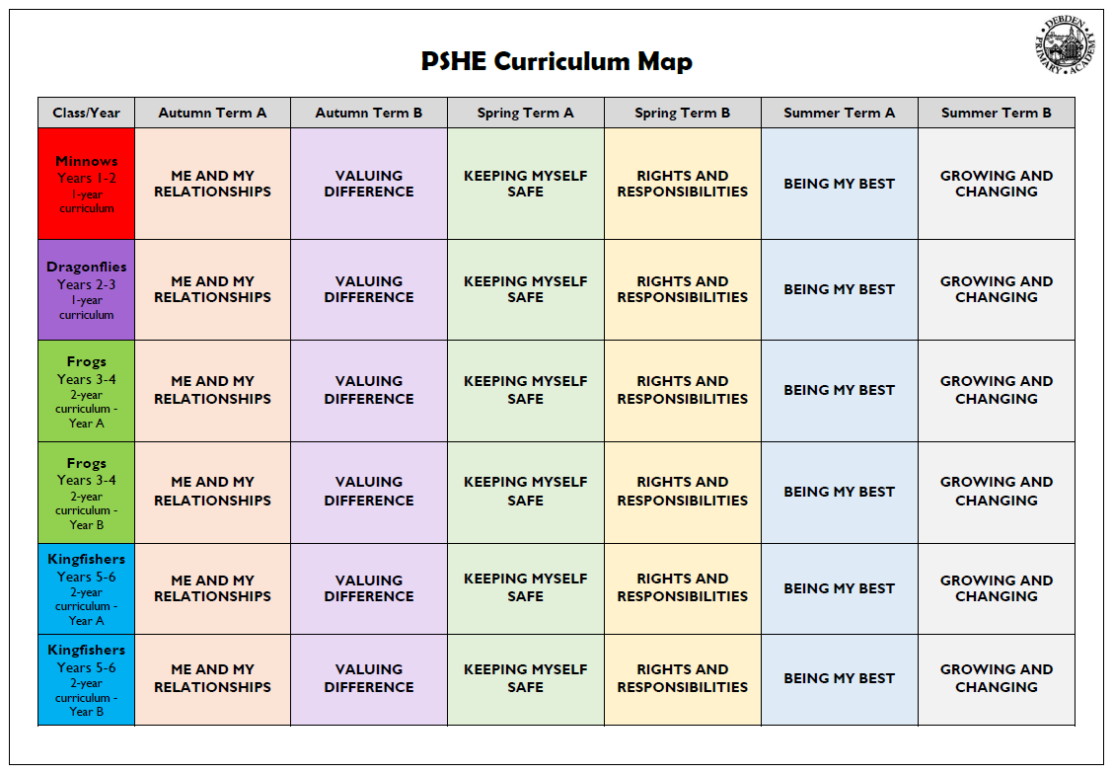
PSHE, Science and Computing Curriculum Maps

Science
Class/Year | Autumn 1 | Autumn 2 |  | Spring 1 | Spring 2 | Summer 1 |  | Summer 2
Minnows  Years 1/2 | EVERYDAY MATERIALS  What are things made from? |  | SEASONAL CHANGE  How does the world around us change throughout the year? |  | PLANTS  What is alive? |  | ANIMALS INCLUDING HUMANS  What are the different types of animals?
Scientist | Ole Kirk Christiansen- Lego inventor  William Addis- Toothbrush Inventor |  | Dr Steve Lyons - Extreme Weather |  | Beatrix Potter |  | Jane Goodall  Chris Packham
Dragonflies  Years 2/3 | USES OF EVERYDAY MATERIALS  How do we choose materials? |  | LIVING THINGS AND THEIR HABITATS  How do living things survive in their habitats? |  | PLANTS  How do plants grow and what do they need to survive? |  | ANIMALS INCLUDING HUMANS  How are animals different and how do they change as they grow?
Scientist | Charles Macintosh |  | Liz Bonnin |  | Captain Cook- Botanists  Agnes Arber Botanist |  | Steve Irwin
Frogs | ROCKS  What can rocks and fossils tell us about the Earth? | FORCES  How do forces affect the way things move? |  | LIGHT  How can we use light to create and change what we see? | PLANTS  How do plants grow, survive, and reproduce? |  | ANIMALS INCLUDING HUMANS  Why do humans and animals need the right food to grow, move, and stay healthy?
Scientist | Mary Anning | Isaac Newton (gravity) |  | Ibn al-Haytham (Alhazen) (c.965–1040)  An early scientist from the Islamic Golden Age. | Joseph Banks – Botanist |  | Marie Maynard Daly (1921–2003)  American biochemist who studied how food and diet affect the body.
Newts | STATES OF MATTER  Is water always wet?  (Rocks this year) | SOUND  How do we hear different things? |  | ELECTRICITY  How does electricity make things work? | LIVING THINGS AND THEIR HABITATS  How can we identify different living things? |  | ANIMALS INCLUDING HUMANS  What do our bodies do with the food we eat?
Scientist | Spencer Silver (invented glue) | Alexander Bell |  | Thomas Edison | Carl Linnaeus  Libby Hyman – Classification |  | William Harvey
Kingfishers A | EVOLUTION AND INHERITANCE  How do living things change over time and place? | EARTH AND SPACE  How do the movements of the Earth and the moon affect our lives? |  | ELECTRICITY  How do we generate and use electricity in the world around us? | LIVING THINGS AND THEIR HABITATS (5)  Do all lifecycles look the same? |  | ANIMALS INCLUDING HUMANS (5)  How do our bodies change as we get older?
Scientist | Charles Darwin and Alfred  Wallace (theory of evolution) | Galileo Galilei (astronomer)  Nicolas Copernicus |  | Michael Faraday | David Attenborough  (naturist) |  | Aristotle-one of the first to write about human reproduction
Kingfishers  B | PROPERTIES OF CHANGE  Can we change materials without changing what they are? | FORCES  How do forces affect the way things move? |  | LIGHT  How can we use light to create and change what we see? | LIVING THINGS AND THEIR HABITATS (6)  What’s the same and what’s different? |  | ANIMALS INCLUDING HUMANS (6)  How do the choices we make affect our bodies and our health?
Scientist | Alexander Fleming (1881–1955)  Discovered penicillin — a chemical material from mould that changed medicine. | Galileo Galilei (1564–1642)  Discovered that all objects fall at the same rate (without air resistance). |  | Isaac Newton | Jane Goodall-Animal behaviour |  | William Harvey  The first scientist to describe how blood circulates around the body.  Discovered that the heart acts as a pump, moving blood through arteries and veins

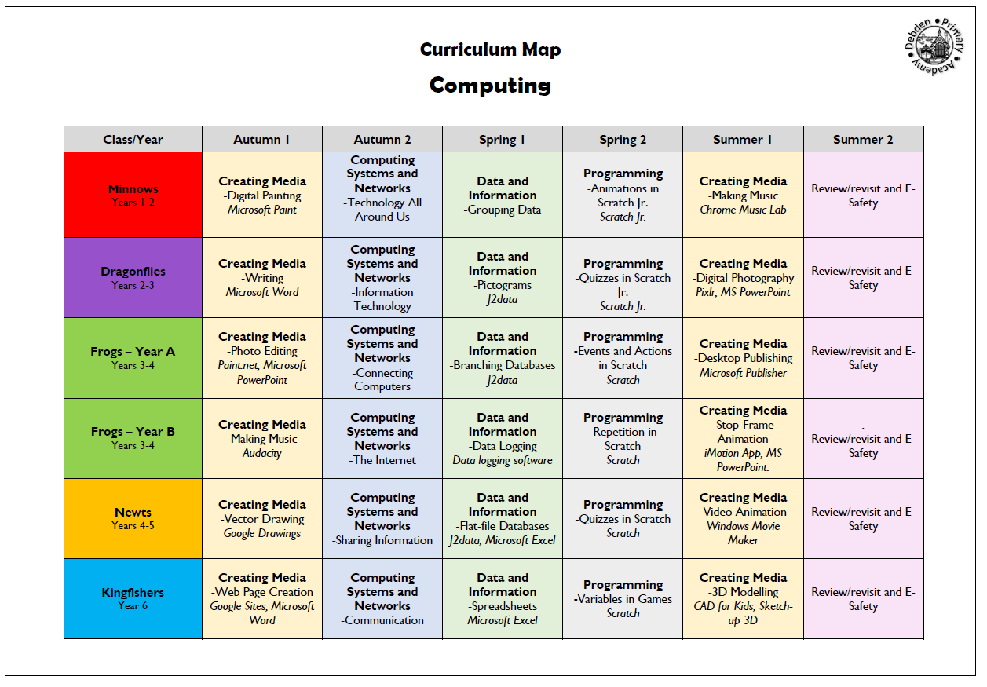

APPENDIX 2
Parent Withdrawal Form – Non-Statutory Elements of RSE Education
Parents have a right to withdraw their children from only the non-statutory sex education elements of the SRE curriculum – this content is outlined in the three bullet points under ‘Non-Statutory Sex Education’ in our SRE policy. If you have spoken to your child’s class teacher about this matter, and you would still like to remove your child from the non-statutory sex education elements of the curriculum, please complete the form below
SECTION A – to be completed by parents
Name of Child |  | Class
Name of Parent |  | Date
Reason/s for withdrawing from sex education within RSE Education
Any other information that you would like the school to consider
Parent Signature: |  |  | Date:

